Report - Assignment 1
Daniel Valenzuela
daniel.val41@mail.com
Challenge: Enhance!

- The challenge request the analysis of an image, the download file was a SVG file.
- The SGV file contains code to draw a white background, black circle with a white dot in the middle.

- The first attempt was just by analyzing the image, select everything, zoom in/out, and I didn´t came with a result more than a little dot in the middle of the image.
- The next step was to look at the code in the file, and there was an area defining text on the image. There was a message on the image but with a small font in the center of the image.
**The same result could be obtained by just select everything on the web page, copy and paste on a notepad as “p i c o C T F { 3 n h 4 n c 3 d _ a a b 7 2 9 d d }”**

- As the name of the Challenge, I changed a little bit of the code to enhance the size of the letters and de display arrangement with the next result:

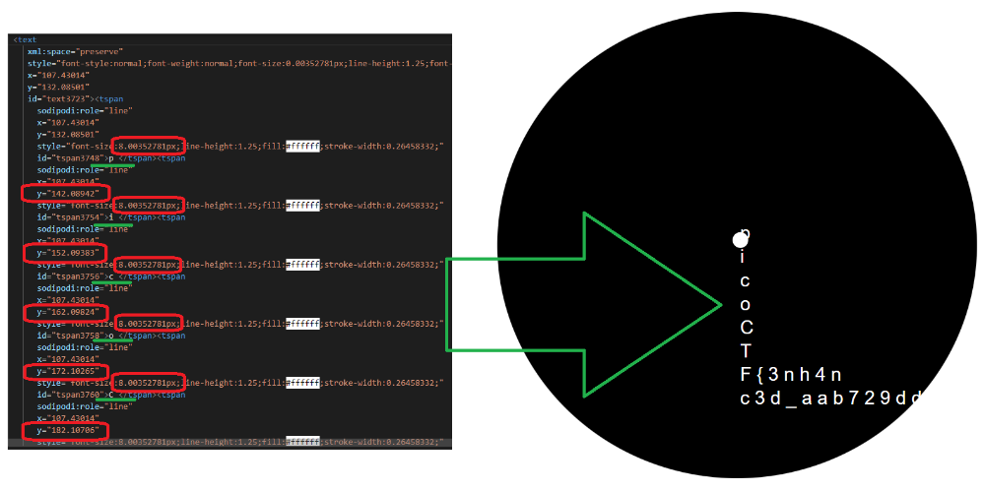

- With that change, I was able to read the flag of the challenge:
The flag is: “picoCTF{3nh4nc3d_aab729dd}”

- In this exercise, the technic of trying to hide something valuable on an image can be categorized as a Steganography Attack, which can be a form of an Obfuscation Attack.

